

LSO Sonata Test Requirements December 2020MEF W92.1 draft 0.1Contribution Number

Working Draft

MEF W92.1 draft 0.1

LSO Sonata Test Requirements

December 2020

This draft represents MEF work in progress and is subject to change.

Disclaimer

© MEF Forum 2020. All Rights Reserved.

The information in this publication is freely available for reproduction and use by any recipient and is believed to be accurate as of its publication date. Such information is subject to change without notice and MEF Forum (MEF) is not responsible for any errors. MEF does not assume responsibility to update or correct any information in this publication. No representation or warranty, expressed or implied, is made by MEF concerning the completeness, accuracy, or applicability of any information contained herein and no liability of any kind shall be assumed by MEF as a result of reliance upon such information.

The information contained herein is intended to be used without modification by the recipient or user of this document. MEF is not responsible or liable for any modifications to this document made by any other party.

The receipt or any use of this document or its contents does not in any way create, by implication or otherwise:

1. any express or implied license or right to or under any patent, copyright, trademark or trade secret rights held or claimed by any MEF member which are or may be associated with the ideas, techniques, concepts or expressions contained herein; nor
2. any warranty or representation that any MEF members will announce any product(s) and/or service(s) related thereto, or if such announcements are made, that such announced product(s) and/or service(s) embody any or all of the ideas, technologies, or concepts contained herein; nor
3. any form of relationship between any MEF member and the recipient or user of this document.

Implementation or use of specific MEF standards, specifications, or recommendations will be voluntary, and no Member shall be obliged to implement them by virtue of participation in MEF Forum. MEF is a non-profit international organization to enable the development and worldwide adoption of agile, assured and orchestrated network services. MEF does not, expressly or otherwise, endorse or promote any specific products or services.

# Table of Contents

1 List of Contributing Members 1

2 Abstract 1

3 Sections Ready for CfC Comments 1

4 Terminology and Abbreviations 4

5 Compliance Levels 5

6 Numerical Prefix Conventions 5

7 Introduction 6

7.1 Explanation of Document Formatting 8

8 Address Validation Test Requirements and Test Cases 10

8.1 Address Validation Sequence Diagram 10

8.2 MEF 79, MEF 79.0.1, and MEF 79.0.2 Requirements 10

8.2.1 MEF 79 Requirements 10

8.2.2 MEF 79.0.1 Requirements 15

8.2.3 MEF 79.0.2 Requirements 15

8.3 Address Validation Test Cases 17

8.3.1 Validating Fielded Address with Unknown ID Method 17

8.3.2 Validating Fielded Address with Known ID Method 18

8.3.3 Validating Formatted Address with Unknown ID Method 19

8.3.4 Validating Formatted Address with Known ID Method 20

8.3.5 Validating Geographic Address Acronym with Unknow ID Method 21

8.3.6 Validating Geographic Address Identifier with Known ID Method 22

8.3.7 Validating Geographic Point Address with Unknown ID Method 22

8.3.8 Validating Geographic Point with Known ID Method 23

9 Site Retrieval Test Requirements and Test Cases 25

9.1 Site Retrieval Sequence Diagram 25

9.2 MEF 79, MEF 79.0.1, and MEF 79.0.2 Requirements 26

9.2.1 MEF 79 Requirements 26

9.2.2 MEF 79.0.1 Requirements 27

9.2.3 MEF 79.0.2 Requirements 27

9.3 Service Site Retrieval Test Cases 27

9.3.1 Retrieve Service Site List 27

9.3.2 Retrieve Service Site by ID 27

10 Product Offering Qualification Creation 28

10.1 POQ Creation Sequence Diagrams 28

10.2 MEF 79, MEF 79.0.1, and MEF 79.0.2 Requirements 30

10.2.1 MEF 79 Requirements 30

10.2.2 MEF 79.0.1 Requirements 31

10.2.3 MEF 79.0.2 Requirements 32

10.3 POQ Creation Test Cases 32

10.3.1 Create POQ Product Action = INSTALL Test Cases 32

10.3.2 Create POQ Product Action = CHANGE Test Cases 32

10.3.3 Create POQ Product Action = DISCONNECT Test Cases 32

11 Product Offering Qualification Retrieval 33

11.1 POQ Retrieval Sequence Diagrams 33

11.1.1 Retrieve POQ List Sequence Diagram 33

11.1.2 Retrieve POQ by ID Sequence Diagram 33

11.2 MEF 79, MEF 79.0.1, and MEF 79.0.2 Requirements 34

11.2.1 MEF 79 Requirements 34

11.2.2 MEF 79.0.1 Requirements 36

11.2.3 MEF 79.0.2 Requirements 36

11.3 Retrieve POQ List Test Cases 36

11.3.1 Retrieve POQ List POQ State 36

11.3.2 Retrieve POQ List Date Range 36

11.3.3 Retrieve POQ List Project Identifier 36

11.4 Retrieve POQ by Identifier Test Cases 36

11.4.1 Retrieve POQ by Identifier Test Cases 36

12 Product Offering Qualification Notification 37

12.1 Product Offering Qualification Notification Sequence Diagrams 37

12.1.1 Register for POQ Notifications 37

12.1.2 POQ Notification Sequence Diagram 37

12.2 MEF 79, MEF 79.0.1, and MEF 79.0.2 Requirements 38

12.2.1 MEF 79 Requirements 38

12.2.2 MEF 79.0.1 Requirements 38

12.2.3 MEF 79.0.2 Requirements 38

12.3 POQ Notification Test Cases 38

12.4 Register for POQ Notifications Request Test Cases 38

13 Product Quote Creation 39

13.1 Product Create Quote Sequence Diagram 39

13.1.1 Product Quote Create with Immediate Response = TRUE Sequence Diagram 39

13.1.2 Product Quote Create with Immediate Response = FALSE Sequence Diagram 41

13.1.3 Product Quote Create with Immediate Response = FALSE Immediate Response Sequence Diagram 41

13.1.4 Cancel Quote Sequence Diagram 43

13.1.5 Reject Quote Sequence Diagram 43

13.2 MEF W80 Requirements 43

13.2.1 Create Quote Requirements 43

13.2.2 MEF W80 Cancel or Reject Quote Requirements 48

13.3 Product Quote Create Test Cases 48

13.3.1 Request Create Product Quote with Immediate Response = TRUE 48

13.3.2 Request Create Product Quote with Immediate Response = FALSE 48

13.3.3 Response Create Product Quote with Immediate Response = FALSE Immediate Response 48

13.3.4 Request Cancel Product Quote 48

13.3.5 Buyer Request Reject Product Quote 48

13.3.6 Response Reject Product Quote 48

14 Product Quote Retrieval 49

14.1 Product Quote Retrieval Sequence Diagrams 49

14.1.1 Retrieve Product Quote List Sequence Diagram 49

14.1.2 Retrieve Product Quote by Quote ID Sequence Diagram 49

14.2 MEF W80 Requirements 50

14.2.1 Retrieve Product Quote 50

14.2.2 MEF W80 Retrieve Product Quote by Quote ID Requirements 50

14.3 Retrieve Product Quote Test Cases 51

14.3.1 Retrieve Product Quote List Test Case 51

14.3.2 Retrieve Product Quote by Quote ID Test Case 51

15 Product Quote Notification 52

15.1 Product Quote Notification Sequence Diagrams 52

15.1.1 Register for Product Notification Sequence Diagram 52

15.1.2 Send Product Quote Notification Sequence Diagram 52

15.2 MEF W80 Requirements 52

15.2.1 Register for Product Quote Notifications Requirements 53

15.2.2 MEF W80 Send Product Quote Notifications Requirements 53

15.3 Product Quote Notification Test Cases 53

15.3.1 Register for Product Quote Notifications Test Case 53

15.3.2 Send Notification Test Case 53

16 Product Inventory 54

16.1 Product Inventory Sequence Diagrams 54

16.1.1 Product Inventory Retrieve Product List Sequence Diagram 54

16.1.2 Product Inventory Retrieve Product by ID Sequence Diagram 54

16.2 MEF 81 and 81.0.1 Requirements 55

16.2.1 Product Inventory Retrieve List Requirements 55

16.2.2 Product Inventory Retrieve Product ID Requirements 56

16.3 Product Inventory Test Cases 57

16.3.1 Product Inventory Retrieve List Test Cases 57

16.3.2 Product Inventory Retrieve Product ID Test Cases 57

17 Product Order Creation, Retrieval, and Notification 58

18 References 59

# List of Figures

Figure 1 – Place to Site and Address Relationship 7

Figure 2 – Address Validation Sequence Diagram 10

Figure 3 – Retrieve Service Site List Sequence Diagram 25

Figure 4 – Retrieve Service Site by ID Sequence Diagram 25

Figure 5 – POQ Creation POQ Activity = INSTALL Sequence Diagram 28

Figure 6 – POQ Creation POQ Activity = CHANGE Sequence Diagram 29

Figure 7 – POQ Creation POQ Activity = DISCONNECT Sequence Diagram 30

Figure 8 – Retrieve POQ List Sequence Diagram 33

Figure 9 – Retrieve POQ by ID 34

Figure 10 – Register for POQ Notifications Sequence Diagram 37

Figure 11 – POQ Notification 37

Figure 12 – Product Quote Create with Immediate Response = TRUE Sequence Diagram 40

Figure 13 – Product Quote Create With Immediate Response = FALSE Sequence Diagram 41

Figure 14 – Product Quote Create With Immediate Response = FALSE, Immediate Response Sequence Diagram 42

Figure 15 – Cancel Quote Sequence Diagram 43

Figure 16 – Reject Quote Sequence Diagram 43

Figure 17 – Retrieve Product Quote List Sequence Diagram 49

Figure 18 – Retrieve Product Quote by Quote ID Sequence Diagram 50

Figure 19 – Register for Quote Notifications Sequence Diagram 52

Figure 20 – Send Product Quote Notification Sequence Diagram 52

Figure 21 – Product Inventory Retrieve Product List Sequence Diagram 54

Figure 22 – Product Inventory Retrieve Product by ID Sequence Diagram 55

# List of Tables

Table 1 – Sections Ready for CfC Comments 3

Table 2 – Terminology and Abbreviations 4

Table 3 – Numerical Prefix Conventions 5

Table 4 – MEF 79 Requirements for Address Validation 15

Table 5 – MEF 79.0.2 Requirements for Address Validation 16

Table 6 - [Test Case 1] Fielded Address Unknown Method Positive Details 17

Table 7 - [Test Case 2] Fielded Address Unknown Method Negative Details 18

Table 8 - [Test Case 3] Fielded Address Known Method Positive Details 18

Table 9 - [Test Case 4] Fielded Address Known Method Negative Details 19

Table 10 - [Test Case 5] Formatted Address Unknown Method Positive Details 19

Table 11 - [Test Case 6] Formatted Address Unknown Method Negative Details 20

Table 12 - [Test Case 7] Formatted Address Known Method Positive Details 20

Table 13 - [Test Case 8] Formatted Address Known Method Negative Details 21

Table 14 – [Test Case 9] Geographic Address Acronym Unknown ID Positive Details 21

Table 15 – [Test Case 10] Geographic Address Acronym Unknown ID Negative Details 21

Table 16 - [Test Case 11] Geographic Address Identifier Known Method Positive Details 22

Table 17 - [Test Case 12] Geographic Address Identifier Known Method Negative Details 22

Table 18 - [Test Case 13] Geographic Point Address Unknown Method Positive Details 23

Table 19 - [Test Case 14] Geographic Point Address Unknown Method Negative Details 23

Table 20 - [Test Case 15] Geographic Point Address Known Method Positive Details 24

Table 21 - [Test Case 16] Geographic Point Address Known Method Negative Details 24

Table 22 – MEF 79 Requirements for Site Retrieval 27

Table 23 – MEF 79.0.2 Requirements for Site Retrieval 27

Table 24 – MEF 79 Requirements for Create POQ 31

Table 25 – MEF 79.0.1 Requirements for Create POQ 32

Table 26 – MEF 79.0.2 Requirements for Create POQ 32

Table 27 – MEF 79 Requirements for Retrieve POQ LIST 34

Table 28 – MEF 79 Requirements for Retrieve POQ by Identifier 35

Table 29 – MEF 79.0.2 Requirements for Retrieve POQ by Identifier 36

Table 30 – MEF 79 Requirements for Register for POQ Notification of State Change 38

Table 31 – MEF 79 Requirements for POQ Notification 38

Table 32 – MEF 80 Requirements for Create Quote 48

Table 33 – MEF 80 Requirements for Cancel or Reject Quote 48

Table 34 – MEF 80 Requirements for Retrieve Product Quote 50

Table 35 – MEF 80 Requirements for Retrieve Product Quote by Quote ID 51

Table 36 – MEF 80 Requirements for Register for Product Notifications 53

Table 37 – MEF 80 Requirements for Send Notifications 53

Table 38 – Product Inventory Retrieve List Requirements 56

Table 39 – Product Inventory Retrieve Product ID Requirements 56

# List of Contributing Members

The following members of the MEF participated in the development of this document and have requested to be included in this list.

1. This list will be finalized before Letter Ballot. Any member that comments in at least one CfC is eligible to be included by opting in before the Letter Ballot is initiated. Note it is the MEF member that is listed here (typically a company or organization), not their individual representatives.

* ABC Networks
* XYZ Communications

# Abstract

This document contains the test requirements for the LSO Sonata Interface Reference Point. Functions addressed within this document are Address Validation (defined in MEF 79 [5] and MEF 79.0.2 [7]), Product Offering Qualification (defined in MEF 79 [5] and MEF 79.0.1 [6]), Quote (defined in MEF 80 [8]), Product Inventory (defined in MEF 81 [9] and MEF 81.0.1 [10]) and Product Order (defined in MEF 57.2 [4]). This document is an important aid to Service Providers and technology solution providers to prepare for successful completion of the conformance certification of the Sonata APIs defined in these documents.

The Test Requirements contained within this document are intended to provide guidance for inter-operation between providers and as a basis for the certification test plan developed by the Certification Test Partner.

# Sections Ready for CfC Comments

Table 1 identifies the sections of the document that are ready for CfC comments. Please do not comment on other sections of the document.

| Section | Sub-section | Sub-Section | Reviewed |
| --- | --- | --- | --- |
| 2 | | |  |
| 6 | 6.1 | |  |
| 7 | 7.1 | |  |
| 7.2 | 7.2.1 |  |
| 7.2.2 |  |
| 7.2.3 |  |
| 7.3 | 7.3.1 |  |
| 7.3.2 |  |
| 7.3.3 |  |
| 7.3.4 |  |
| 7.3.5 |  |
| 7.3.6 |  |
| 7.3.7 |  |
| 7.3.8 |  |
| 8 | 8.1 | |  |
| 8.2 | 8.2.1 |  |
| 8.2.2 |  |
| 8.2.3 |  |
| 9 | 9.1 | |  |
| 9.2 | 9.2.1 |  |
| 9.2.2 |  |
| 9.2.3 |  |
| 10 | 10.1 | |  |
| 10.2 | 10.2.1 |  |
| 10.2.2 |  |
| 10.2.3 |  |
| 11 | 11.1 | 11.1.1 |  |
| 11.1.2 |  |
| 11.2 | 11.2.1 |  |
| 11.2.2 |  |
| 11.2.3 |  |
| 12 | 12.1 | 12.1.1 |  |
| 12.1.2 |  |
| 12.2 | 12.2.1 |  |
| 12.2.2 |  |
| 12.2.3 |  |
| 13 | 13.1 | 13.1.1 |  |
| 13.1.2 |  |
| 13.1.3 |  |
| 13.1.4 |  |
| 13.1.5 |  |
| 13.2 | 13.2.1 |  |
| 13.2.2 |  |
| 14 | 14.1 | 14.1.1 |  |
| 14.1.2 |  |
| 14.2 | 14.2.1 |  |
| 14.2.2 |  |
| 15 | 15.1 | 15.1.1 |  |
| 15.1.2 |  |
| 15.2 | 15.2.1 |  |
| 15.2.2 |  |
| 16 | 16.1 | 16.1.1 |  |
| 16.1.2 |  |
| 16.2 | 16.2.1 |  |
| 16.2.2 |  |
| 18 | | |  |

Table 1 – Sections Ready for CfC Comments

# Terminology and Abbreviations

This section defines the terms used in this document. In many cases, the normative definitions to terms are found in other documents. In these cases, the third column is used to provide the reference that is controlling, in other MEF or external documents.

In addition, terms defined in MEF 55[3], MEF 79 [5], MEF 79.0.1 [6], MEF 79.0.2 [7], MEF 80 [8], MEF 81 [9], MEF 81.0.1 [10], and MEF 57.2 [4] are included in this document by reference, and are not repeated in the table below.

| Term | Definition | Reference |
| --- | --- | --- |
|  |  |  |
|  |  |  |
|  |  |  |
|  |  |  |
|  |  |  |
|  |  |  |
|  |  |  |
|  |  |  |
|  |  |  |

Table 2 – Terminology and Abbreviations

1. At this time, no new terminology or abbreviations have been identified

# Compliance Levels

The key words "**MUST**", "**MUST NOT**", "**REQUIRED**", "**SHALL**", "**SHALL NOT**", "**SHOULD**", "**SHOULD NOT**", "**RECOMMENDED**", "**NOT RECOMMENDED**", "**MAY**", and "**OPTIONAL**" in this document are to be interpreted as described in BCP 14 (RFC 2119 [1], RFC 8174 [2]) when, and only when, they appear in all capitals, as shown here. All key words must be in bold text.

Items that are **REQUIRED** (contain the words **MUST** or **MUST** **NOT**) are labeled as **[Rx]** for required. Items that are **RECOMMENDED** (contain the words **SHOULD** or **SHOULD** **NOT**) are labeled as **[Dx]** for desirable. Items that are **OPTIONAL** (contain the words **MAY** or **OPTIONAL**) are labeled as **[Ox]** for optional**.**

1. The following paragraph will be deleted if no conditional requirements are used in the document.

A paragraph preceded by **[CRa]<** specifies a conditional mandatory requirement that **MUST** be followed if the condition(s) following the “<” have been met. For example, “**[CR1]<**[D38]” indicates that Conditional Mandatory Requirement 1 must be followed if Desirable Requirement 38 has been met. A paragraph preceded by **[CDb]<** specifies a Conditional Desirable Requirement that **SHOULD** be followed if the condition(s) following the “<” have been met. A paragraph preceded by **[COc]<** specifies a Conditional Optional Requirement that **MAY** be followed if the condition(s) following the “<” have been met.

# Numerical Prefix Conventions

1. This section will be deleted if no numerical prefixes are used in the document.

This document uses the prefix notation to indicate multiplier values as shown in Table 3.

|  |  |  |  |
| --- | --- | --- | --- |
| Decimal | | Binary | |
| Symbol | Value | Symbol | Value |
| k | 103 | Ki | 210 |
| M | 106 | Mi | 220 |
| G | 109 | Gi | 230 |
| T | 1012 | Ti | 240 |
| P | 1015 | Pi | 250 |
| E | 1018 | Ei | 260 |
| Z | 1021 | Zi | 270 |
| Y | 1024 | Yi | 280 |

Table 3 – Numerical Prefix Conventions

# Introduction

The LSO Sonata Interface Reference Point is defined in MEF 55 [3] to connect two providers together. These two parties are known as the Buyer and the Seller within the Sonata Business Requirements and Use Case documents (MEF 79 [5], MEF 79.0.1 [6], MEF 79.0.2 [7], MEF 80 [8], MEF 81 [9], MEF 81.0.1 [10], and MEF 57.2 [4]). This document provides test requirements and test cases for the requirements that are detailed in the Sonata Business Requirements and Use Case suite of documents.

The areas addressed within this document are:

* Address Validation
* Service Site Validation
* Product Offering Qualification (POQ)
* Quote
* Product Ordering
* Product Inventory

Each of these areas are addressed in detail within this document, deriving test requirements and test cases from the Business Requirements and Use Cases for each area. It should be noted that this document does not attempt to provide test requirements and test cases for every possible interaction between Buyer and Seller. The test cases represent either “sunny day” or positive scenarios or “cloudy day” or negative scenarios for each of these areas. All possible errors are not included in the test cases. Requirements from the suite of Sonata Business Requirements and Use Case documents are identified as either tested or not tested.

Address Validation includes Geographic Address Retrieval and Validation. Different address types (Fielded Address, Formatted Address, Geographic Points, and Geographic Address Identifier) for locations are included in the test requirements and test cases. Buyers validate that a Geographic Address is valid within the Seller’s systems and then retrieve information about the Geographic Address using the Seller provided Address ID.

Note: Place is the term used to describe a specific address or location.

Service Site Validation allows the Buyer to determine if the Seller has created a Service Site at a given address and return the details about that Service Site. If a Service Site exists, the Buyer may refer to the Service Site Identifier for all other parts of the pre-ordering and ordering processes.

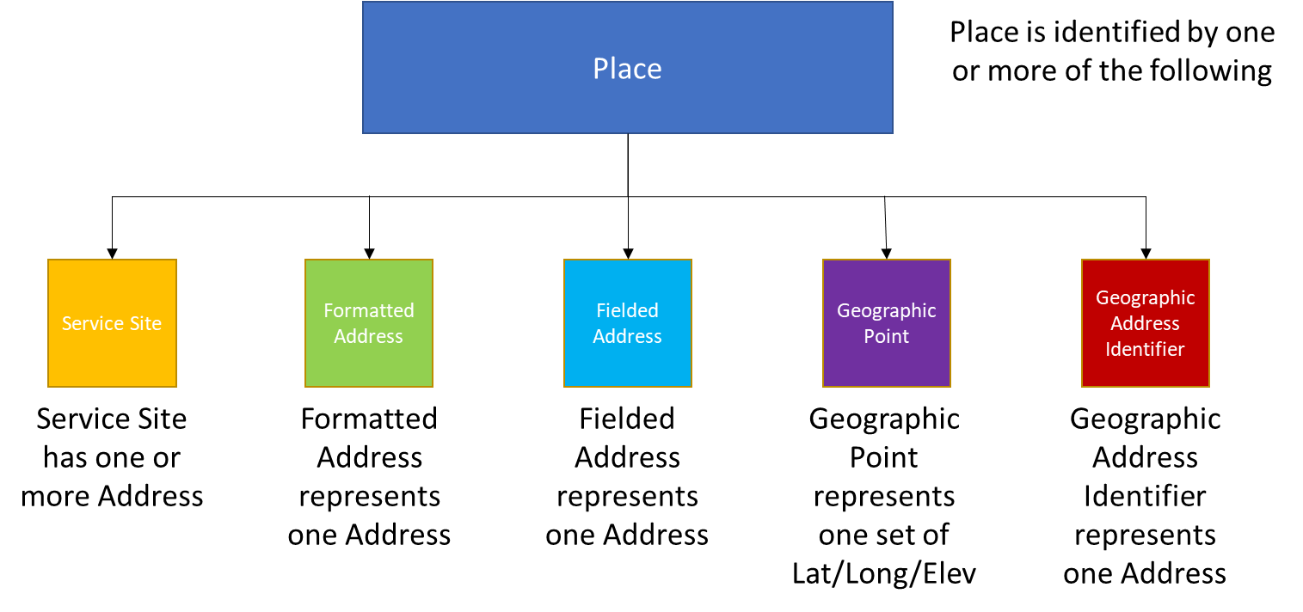

Figure 1 – Place to Site and Address Relationship

Figure 1 shows the relationship between a Place and Service Site or Address. A Place can be identified by one or more Service Sites, Formatted Addresses, or Fielded Addresses. A Geographic Point can be used to identify a single Place that includes the Latitude, Longitude, and Elevation. A Geographic Address Identifier can be used to identify a single Place.

The Buyer uses a POQ to determine if the Seller can support one or more Products at a given address. Test requirements and test cases verify that the Buyer is able to create a POQ, retrieve a list of POQs based on Buyer specified filter criteria, retrieve the details on a specific POQ ID, register for the Seller to send them notifications on POQs, that the Seller responds correctly to requests from the Buyer, and that the Seller sends notifications on POQs correctly.

The Buyer requests a Quote to determine the pricing for one or more Products. Test requirements and test cases verify that the Buyer is able to create, cancel, or reject a Quote, retrieve a list of Quotes based on Buyer specific filter criteria, retrieve details on a specific Quote ID, register for the Seller to send them notifications on Quotes, that the Seller responds correctly to requests from the Buyer, and that the Seller sends notifications on Quotes correctly.

The Buyer uses Product Orders to request Product Fulfillment from a Seller. Test requirements and test cases verify that the Buyer is able to create, cancel, or modify an Order, retrieve a list of Orders based on Buyer specific filter criteria, retrieve details on a specific Order ID, register for the Seller to send them notifications on Order, that the Seller responds correctly to requests from the Buyer, and that the Seller sends notifications on Orders correctly.

The Buyer uses Product Inventory to retrieve information from the Seller about a Product ID. Test requirements and test cases verify that the Buyer is able to retrieve a list of Products matching Buyer filter criteria, retrieve a specific Product by Product ID, and that the Seller responds correctly to requests from the Buyer.

## Explanation of Document Formatting

Each section of this document, which covers a part of the pre-order or order process, is divided into sub-sections. Each section contains applicable sequence diagrams which provide a high-level view of the process described in that section of the document.

This is followed by a table or tables with all requirements from the applicable Business Requirement and Use Case document(s) that address the portion of the process covered in the section. These tables are all formatted as follows:

* Requirement number
* Entity which indicates if this requirement is included in verification of the
  + Seller implementation (shown by an S)
  + Buyer implementation (shown by a B)
  + Both implementations (shown by a SB).
* Each requirement is identified as Tested yes or no.
  + Y indicates that the requirement is verified by the test requirements and test cases
  + N indicates that the requirement is not verified by the test requirements and test cases.
* The Test Case(s) which are used to verify the requirement
* The applicable API which has implemented the requirement
* Any comments

For the purpose of this document, a requirement that is shown as Tested = Y is verified in one or more Test Cases. A requirement that is shown as Tested = N is considered either desirable or optional for an implementation. As an example, a requirement that indicates a Buyer or Seller should or may include attributes in their request or response is not tested. A requirement that mandates that the Buyer or Seller include attributes in their request or response is tested.

Each section then continues with the Test Cases that are used to verify that the requirements indicated as Tested = Y are implemented correctly. Each table that defines a Test Case includes the following:

* Entity which describes if this is a Buyer or Seller request, response, or notification
* TC Step which describes what occurs in this step of the Test Case
* Verified Requirements which define which requirements are verified by this Test Case
* Any comments

Each Test Case is followed by references to sample JSON GET or POST functions. These can be used by anyone developing a test plan to define the steps in the test plan.

1. POSTMAN scripts will be provided in a later release of the document.

# Address Validation Test Requirements and Test Cases

The Address Validation test requirements and test cases are defined in this section.

## Address Validation Sequence Diagram

The Address Validation Sequence Diagram is shown in Figure 2.

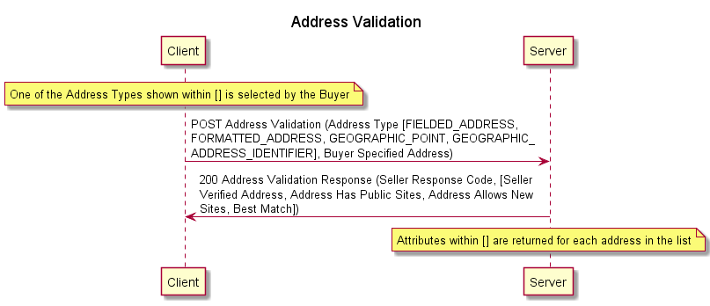

Figure 2 – Address Validation Sequence Diagram

## MEF 79, MEF 79.0.1, and MEF 79.0.2 Requirements

All Address Validation requirements from MEF 79 [5], MEF 79.0.1 [6], and MEF 79.0.2 [7] are shown in the following tables.

### MEF 79 Requirements

The requirements from MEF 79 [5] are shown in Table 4.

| Requirement | Entity | Tested | Test Case(s) | API Version | Comment |
| --- | --- | --- | --- | --- | --- |
| R1 | S | Y |  |  |  |
| D1 | B | N |  |  |  |
| D2 | B | N |  |  |  |
| D3 | B | N |  |  |  |
| D4 | B | N |  |  |  |
| D5 | S | Y |  |  |  |
| D6 | S | Y |  |  |  |
| CR1<D6 | S | Y |  |  |  |
| R2 | S | Y | [Test Case 1] [Test Case 5] [Test Case 13] | geographicAddressManagement.api.yaml v6 |  |
| R4 | B | Y | [Test Case 1], [Test Case 2], [Test Case 3], [Test Case 4], [Test Case 5], [Test Case 6] [Test Case 7], [Test Case 8], [Test Case 11], [Test Case 12], [Test Case 13], [Test Case 14], [Test Case 15], [Test Case 16] | geographicAddressManagement.api.yaml v6 |  |
| R5 | B | Y | [Test Case 1], [Test Case 3] | geographicAddressManagement.api.yaml v6 |  |
| R6 | B | Y | [Test Case 4] | geographicAddressManagement.api.yaml v6 |  |
| R7 | B | Y | [Test Case 2] [Test Case 5] [Test Case 6] | geographicAddressManagement.api.yaml v6 |  |
| R8 | B | Y | [Test Case 4] | geographicAddressManagement.api.yaml v6 |  |
| R9 | S | Y | [Test Case 1], [Test Case 2], [Test Case 3], [Test Case 4], [Test Case 5], [Test Case 6] [Test Case 7], [Test Case 8], [Test Case 11], [Test Case 12], [Test Case 13], [Test Case 14], [Test Case 15], [Test Case 16] | geographicAddressManagement.api.yaml v6 |  |
| R10 | S | Y | [Test Case 1] [Test Case 3] | geographicAddressManagement.api.yaml v6 |  |
| R11 | S | Y | [Test Case 5] [Test Case 7] | geographicAddressManagement.api.yaml v6 |  |
| R12 | S | Y | [Test Case 1] [Test Case 5] [Test Case 13] [Test Case 15] | geographicAddressManagement.api.yaml v6 |  |
| R13 | S | Y | [Test Case 3] [Test Case 7] | geographicAddressManagement.api.yaml v6 |  |
| R14 | S | Y | [Test Case 2], [Test Case 4], [Test Case 6] [Test Case 8], [Test Case 12], [Test Case 14], [Test Case 16] | geographicAddressManagement.api.yaml v6 |  |
| O1 | S | N |  |  |  |
| R15 | S | Y | [Test Case 1], [Test Case 3], [Test Case 5], [Test Case 7], [Test Case 11], [Test Case 13], [Test Case 15] | geographicAddressManagement.api.yaml v6 |  |
| R16 | S | Y | [Test Case 1], [Test Case 3], [Test Case 5], [Test Case 7], [Test Case 11], [Test Case 13], [Test Case 15] | geographicAddressManagement.api.yaml v6 |  |
| R84 | B | Y | [Test Case 1][Test Case 5] | geographicAddressManagement.api.yaml v6 |  |
| R85 | S | Y | [Test Case 1] [Test Case 5] | geographicAddressManagement.api.yaml v6 |  |
| R86 | SB | Y | [Test Case 1] | geographicAddressManagement.api.yaml v6 |  |
| R87 | SB | Y | [Test Case 5] | geographicAddressManagement.api.yaml v6 |  |
| R88 | B | Y | [Test Case 1] [Test Case 3] | geographicAddressManagement.api.yaml v6 | Conditional if Fielded Address Supported |
| R89 | B | Y | [Test Case 2] | geographicAddressManagement.api.yaml v6 | Conditional if Fielded Address Supported  Specific to Unknown Address ID |
| R90 | B | Y | [Test Case 1] | geographicAddressManagement.api.yaml v6 | Conditional if Fielded Address Supported  Specific to Unknown Address ID |
| O11 | B | N |  |  | Conditional if Fielded Address Supported |
| R91 | B | Y | [Test Case 3] | geographicAddressManagement.api.yaml v6 | Conditional if Fielded Address Supported  Specific to Known Address ID |
| D7 | S | Y | [Test Case 3] | geographicAddressManagement.api.yaml v6 | Conditional if Fielded Address Supported |
| R92 | S | Y | [Test Case 1] [Test Case 3] | geographicAddressManagement.api.yaml v6 | Conditional if Fielded Address Supported |
| O12 | S | N |  |  | Conditional if Fielded Address Supported |
| R93 | B | Y | [Test Case 5] | geographicAddressManagement.api.yaml v6 | Conditional if Formatted Address Supported |
| R94 | B | Y | [Test Case 5] [Test Case 6] | geographicAddressManagement.api.yaml v6 | Conditional if Formatted Address Supported  Specific to Unknown Address ID |
| R95 | B | Y | [Test Case 5] | geographicAddressManagement.api.yaml v6 | Conditional if Formatted Address Supported  Specific to Unknown Address ID |
| O13 | B | N |  |  | Conditional if Formatted Address Supported  Specific to Unknown Address ID |
| R96 | B | Y | [Test Case 7] [Test Case 8] | geographicAddressManagement.api.yaml v6 | Conditional if Formatted Address Supported  Specific to Known Address ID |
| R97 | B | Y | [Test Case 7] [Test Case 8] | geographicAddressManagement.api.yaml v6 | Conditional if Formatted Address Supported  Specific to Known Address ID |
| D8 | S | Y | [Test Case 7] | geographicAddressManagement.api.yaml v6 | Conditional if Formatted Address Supported |
| R98 | S | Y | [Test Case 5] [Test Case 7] | geographicAddressManagement.api.yaml v6 | Conditional if Formatted Address Supported |
| O14 | S | N |  |  | Conditional if Formatted Address Supported |

Table 4 – MEF 79 Requirements for Address Validation

1. Requirements R89 and R91 in the above table are expected to be modified in MEF W79.0.2. This table will be updated once that is complete.

### MEF 79.0.1 Requirements

There are no applicable requirements in MEF 79.0.1 [6].

### MEF 79.0.2 Requirements

The requirements from MEF 79.0.2 [7] are shown in Table 5.

| Requirement | Entity | Tested | Test Case | API Version | Comment |
| --- | --- | --- | --- | --- | --- |
| A2-R1 | B | Y | [Test Case 13] [Test Case 14] | geographicAddressManagement.api.yaml v6 |  |
| A2-R2 | B | Y | [Test Case 15] [Test Case 16] | geographicAddressManagement.api.yaml v6 |  |
| A2-R3 | B | Y | [Test Case 9] [Test Case 10] |  |  |
| A2-R4 | B | Y | [Test Case 11] | geographicAddressManagement.api.yaml v6 |  |
| A2-R5 | S | Y | [Test Case 13]  [Test Case 15] | geographicAddressManagement.api.yaml v6 |  |
| A2-O1 | S | Y |  |  | If associated address is supported |
| A2-R6 | S | Y | [Test Case 7] [Test Case 11] [Test Case 12] | geographicAddressManagement.api.yaml v6 |  |
| A2-R9 | B | Y | [Test Case 9] [Test Case 10] |  |  |
| A2-R10 | B | Y | [Test Case 11] [Test Case 12] | geographicAddressManagement.api.yaml v6 | Conditional if Geographic Address Identifier Supported |
| A2-R11 | S | Y | [Test Case 11] | geographicAddressManagement.api.yaml v6 | Conditional if Geographic Address Identifier Supported |
| A2-R12 | B | N | [Test Case 13] [Test Case 14] | geographicAddressManagement.api.yaml v6 | Conditional if Geographic Point Supported |
| A2-R13 | B | Y | [Test Case 14] | geographicAddressManagement.api.yaml v6 | Conditional if Geographic Point supported |
| A2-R14 | B | Y | [Test Case 13] | geographicAddressManagement.api.yaml v6 | Conditional if Geographic Point supported |
| A2-O2 | B | N |  |  | Conditional if Geographic Point supported |
| A2-R15 | B | Y | [Test Case 15] | geographicAddressManagement.api.yaml v6 | Conditional if Geographic Point supported |
| A2-R16 | B | Y | [Test Case 16] | geographicAddressManagement.api.yaml v6 | Conditional if Geographic Point supported |
| A2-R17 | S | Y | [Test Case 13] [Test Case 15] | geographicAddressManagement.api.yaml v6 | Conditional if Geographic Point supported |
| A2-R18 | S | Y | [Test Case 13] [Test Case 15] | geographicAddressManagement.api.yaml v6 | Conditional if Geographic Point supported |
| A2-O3 | S | N |  |  | If associated address is supported |

Table 5 – MEF 79.0.2 Requirements for Address Validation

1. Comments have been raised in the MEF W79.0.2 CfC on several requirements shown in this table. The table will be updated once those comments are resolved.

## Address Validation Test Cases

The Address Validation test cases are defined in the following sections.

### Validating Fielded Address with Unknown ID Method

The Address Validating Fielded Address with Unknown Method ID test cases are defined in this section.

1. The Buyer and Seller **MUST** complete [Test Case 1] as shown in Table 6.

|  |  |  |  |
| --- | --- | --- | --- |
| Entity | TC Step | Verified Requirements | Comments |
| Buyer Request | The Buyer submits a Validate Address request with the Address Type attribute of FIELDED_ADDRESS and that includes the Street Name, City, and Country and does not include a Seller Address ID. A Postal Code, must be included in the request if applicable for the specified country. | MEF 79 [5] R4, R5, R84, R85, R86 R88, R89, R90 |  |
| Seller Response | The Buyer receives a 200 response from the Seller indicating success and containing one or more Fielded Addresses that are considered a potential match. Each Address returned must include the Best Match attribute, the Street Name, Street Number, City, and Country. Each Address returned should contain the Fielded Address Identifier. A Postal Code, must be included in the response if applicable for the specified country. | MEF 79 [5] R2, R9, R10, R12, R15, R16, R92 |  |

Table 6 - [Test Case 1] Fielded Address Unknown Method Positive Details

1. The Buyer and Seller **MUST** complete [Test Case 2] as shown in Table 7.

|  |  |  |  |
| --- | --- | --- | --- |
| Entity | TC Step | Verified Requirements | Comments |
| Buyer Request | The Buyer submits a Validate Address request with the Address Type attribute of FIELDED_ADDRESS, Street Name, City, Country, and the Fielded Address Identifier. | MEF 79 [5] R4, R7, R89 |  |
| Seller Response | The Buyer receives a 422 response from the Seller indicating an unexpected attribute was included in the request. | MEF 79 [5]  R9, R14 |  |

Table 7 - [Test Case 2] Fielded Address Unknown Method Negative Details

### Validating Fielded Address with Known ID Method

The Address Validating Fielded Address with Known Method ID test cases are defined in this section. [Test Case 3] is a positive test case. [Test Case 4] is a negative test case. These test cases apply only if the Seller supports a Fielded Address ID.

1. The Buyer and Seller **MUST** complete [Test Case 3] as shown in Table 8.

|  |  |  |  |
| --- | --- | --- | --- |
| Entity | TC Step | Verified Requirements | Comments |
| Buyer Request | The Buyer submits a Validate Address request with the Address Type attribute of FIELDED_ADDRESS and that includes Seller Address ID. | MEF 79 [5] R4, R5, R88, R91 |  |
| Seller Response | The Buyer receives a 200 response from the Seller indicating success and containing one Fielded Address. The Address returned must include the Best Match attribute, the Street Name, Street Number, City, and Country. The Address returned must contain the Fielded Address Identifier. A Postal Code, must be included in the response if applicable for the specified country. | MEF 79 [5] R9, R10, R13, R15, R16, R92, D7 |  |

Table 8 - [Test Case 3] Fielded Address Known Method Positive Details

1. The Buyer and Seller **MUST** complete [Test Case 4] as shown in Table 9.

|  |  |  |  |
| --- | --- | --- | --- |
| Entity | TC Step | Verified Requirements | Comments |
| Buyer Request | The Buyer submits a Validate Address request with the Address Type attribute of FIELDED_ADDRESS that includes Seller Address ID and the Street Number. | MEF 79 [5] R4, R6  MEF 79.0.2 [7] A2-R? |  |
| Seller Response | The Buyer receives a 422 response from the Seller. | MEF 79 [5]  R9, R14 |  |

Table 9 - [Test Case 4] Fielded Address Known Method Negative Details

### Validating Formatted Address with Unknown ID Method

The Address Validating Formatted Address with Unknown Method ID test cases are defined in this section.

1. The Buyer and Seller **MUST** complete [Test Case 5] as shown in Table 10.

|  |  |  |  |
| --- | --- | --- | --- |
| Entity | TC Step | Verified Requirements | Comments |
| Buyer Request | The Buyer submits a Validate Address request with the Address Type attribute of FORMATTED_ADDRESS and that includes the Address Line 1 and Country and does not include a Seller Address ID. | MEF 79 [5] R4, R7, R84, R85, R87, R93, R94, R95 |  |
| Seller Response | The Buyer receives a 200 response from the Seller indicating success and containing one or more Formatted Addresses that are considered a potential match. Each Address returned must include the Best Match attribute, Address Line 1 and Country. Each Address returned should contain the Formatted Address Identifier. | MEF 79 [5] R2, R9, R11, R12, R15, R16, R98 |  |

Table 10 - [Test Case 5] Formatted Address Unknown Method Positive Details

1. The Buyer and Seller **MUST** complete [Test Case 6] as shown in Table 11.

|  |  |  |  |
| --- | --- | --- | --- |
| Entity | TC Step | Verified Requirements | Comments |
| Buyer Request | The Buyer submits a Validate Address request with the Address Type attribute of FORMATTED_ADDRESS and that includes the Formatted Address Identifier, Address Line 1, and Country. | MEF 79 [5] R4, R7, R94 |  |
| Seller Response | The Buyer receives a 422 response from the Seller indicating an unexpected attribute was included in the request. | MEF 79 [5]  R9, R14 |  |

Table 11 - [Test Case 6] Formatted Address Unknown Method Negative Details

### Validating Formatted Address with Known ID Method

The Address Validating Formatted Address with Known Method ID test cases are defined in this section. [Test Case 7] is a positive test case. [Test Case 8] is a negative test case. These test cases apply only if the Seller supports a Formatted Address ID.

1. The Buyer and Seller **MUST** complete [Test Case 7] as shown in Table 12.

|  |  |  |  |
| --- | --- | --- | --- |
| Entity | TC Step | Verified Requirements | Comments |
| Buyer Request | The Buyer submits a Validate Address request with the Address Type attribute of FORMATTED_ADDRESS and that includes Seller Address ID. | MEF 79 [5] R4, R8, R96, R97 |  |
| Seller Response | The Buyer receives a 200 response from the Seller indicating success and containing one Formatted Address. The Address returned must include the Best Match attribute, Address Line 1, and Country. The Address returned must contain the Formatted Address Identifier. | MEF 79 [5]  R9, R11, R13, R15, R16, R98, D8  MEF 79.0.2 [7] A2-R6 |  |

Table 12 - [Test Case 7] Formatted Address Known Method Positive Details

1. The Buyer and Seller **MUST** complete [Test Case 8] as shown in Table 13.

|  |  |  |  |
| --- | --- | --- | --- |
| Entity | TC Step | Verified Requirements | Comments |
| Buyer Request | The Buyer submits a Validate Address request with the Address Type attribute of FORMATTED_ADDRESS that includes Seller Address ID and the Address Line 1. | MEF 79 [5] R4, R8, R96, R97 |  |
| Seller Response | The Buyer receives a 422 response from the Seller. | MEF 79 [5]  R9, R14 |  |

Table 13 - [Test Case 8] Formatted Address Known Method Negative Details

### Validating Geographic Address Acronym with Unknow ID Method

The Address Validating Geographic Address Identifier with Known Method ID test cases are defined in this section. [Test Case 11] is a positive test case. [Test Case 12] is a negative test case.

1. The Buyer AND Seller **MUST** complete [Test Case 9] as shown in Table 14.

|  |  |  |  |
| --- | --- | --- | --- |
| Entity | TC Step | Verified Requirements | Comments |
| Buyer Request | The Buyer submits a Validate Address request with the Address Type attribute of GEOGRAPHIC_ADDRESS_ACRONYM and that includes the Geographic Address Acronym, and Administrative Authority. | MEF 79 [5] R4  MEF 79.0.2 [7] A2-R3, A2-R9 |  |
| Seller Response | The Buyer receives a 200 response from the Seller indicating success and containing one Geographic Address Identifier. The Address returned must include the Best Match attribute, Geographic Address Identifier ID and Administrative Authority. | MEF 79 [5]  R9, R15, R16  MEF 79.0.2 [7] A2-R6, A2-R11 |  |

Table 14 – [Test Case 9] Geographic Address Acronym Unknown ID Positive Details

1. The Buyer and Seller **MUST** complete [Test Case 10] as shown in Table 15.

|  |  |  |  |
| --- | --- | --- | --- |
| Entity | TC Step | Verified Requirements | Comments |
| Buyer Request | The Buyer submits a Validate Address request with the Address Type attribute of GEOGRAPHIC_ADDRESS_IDENTIFIER that includes Geographic Address Acronym but not the Administrative Authority. | MEF 79 [5] R4  MEF 79.0.2 [7] A2-R3, A2-R9 |  |
| Seller Response | The Buyer receives a 422 response from the Seller. | MEF 79 [5]  R9, R14 |  |

Table 15 – [Test Case 10] Geographic Address Acronym Unknown ID Negative Details

### Validating Geographic Address Identifier with Known ID Method

The Address Validating Geographic Address Identifier with Known Method ID test cases are defined in this section. [Test Case 11] is a positive test case. [Test Case 12] is a negative test case. These test cases apply only if the Seller supports a Geographic Address ID.

1. The Buyer and Seller **MUST** complete [Test Case 11] as shown in Table 16.

|  |  |  |  |
| --- | --- | --- | --- |
| Entity | TC Step | Verified Requirements | Comments |
| Buyer Request | The Buyer submits a Validate Address request with the Address Type attribute of GEOGRAPHIC_ADDRESS_IDENTIFIER and that includes the Geographic Address Identifier. | MEF 79 [5] R4  MEF 79.0.2 [7] A2-R4, A2-R10 |  |
| Seller Response | The Buyer receives a 200 response from the Seller indicating success and containing one Geographic Address Identifier. The Address returned must include the Best Match attribute, Geographic Address Identifier, Geographic Address Acronym, and Administrative Authority. | MEF 79 [5]  R9, R15, R16  MEF 79.0.2 [7] A2-R6, A2-R11 |  |

Table 16 - [Test Case 11] Geographic Address Identifier Known Method Positive Details

1. The Buyer and Seller **MUST** complete [Test Case 12] as shown in Table 17.

|  |  |  |  |
| --- | --- | --- | --- |
| Entity | TC Step | Verified Requirements | Comments |
| Buyer Request | The Buyer submits a Validate Address request with the Address Type attribute of GEOGRAPHIC_ADDRESS_IDENTIFIER that includes Geographic Address Identifier ID and the Administrative Authority. | MEF 79 [5] R4  MEF 79.0.2 [7] A2-R10 |  |
| Seller Response | The Buyer receives a 422 response from the Seller. | MEF 79 [5]  R9, R14 |  |

Table 17 - [Test Case 12] Geographic Address Identifier Known Method Negative Details

### Validating Geographic Point Address with Unknown ID Method

The Address Validating Geographic Point Address with Unknown Method ID test cases are defined in this section. [Test Case 13] is a positive test case. [Test Case 14] is a negative test case.

1. The Buyer and Seller **MUST** complete [Test Case 13] as shown in Table 18.

|  |  |  |  |
| --- | --- | --- | --- |
| Entity | TC Step | Verified Requirements | Comments |
| Buyer Request | The Buyer submits a Validate Address request with the Address Type attribute of GEOGRAPHIC_POINT and that includes the Spatial Reference, Latitude, and Longitude and does not include a Geographic Point Identifier. | MEF 79 [5] R4  MEF 79.0.2 [7] A2-R1, A2-R12, A2-R14 |  |
| Seller Response | The Buyer receives a 200 response from the Seller indicating success and containing one or more Geographic Points that are considered a potential match. Each Geographic Point returned must include the Best Match attribute, Geographic Point Identifier, Spatial Reference, Latitude, and Longitude. | MEF 79 [5] R2, R9, R12, R15, R16,  MEF 79.0.2 [7] A2-R5, A2-R17, A2-R18 |  |

Table 18 - [Test Case 13] Geographic Point Address Unknown Method Positive Details

1. The Buyer and Seller **MUST** complete [Test Case 14] as shown in Table 19.

|  |  |  |  |
| --- | --- | --- | --- |
| Entity | TC Step | Verified Requirements | Comments |
| Buyer Request | The Buyer submits a Validate Address request with the Address Type attribute of GEOGRAPHIC_POINT and that includes the Geographic Point Identifier, Spatial Reference, Latitude, and Longitude. | MEF 79 [5] R4  MEF 79.0.2 [7] A2-R1, A2-R12, A2-R13 |  |
| Seller Response | The Buyer receives a 422 response from the Seller indicating an unexpected attribute was included in the request. | MEF 79 [5] R9, R14 |  |

Table 19 - [Test Case 14] Geographic Point Address Unknown Method Negative Details

### Validating Geographic Point with Known ID Method

The Address Validating Geographic Point Address with Known Method ID test cases are defined in this section. [Test Case 15] is a positive test case. [Test Case 16] is a negative test case.

1. The Buyer and Seller **MUST** complete [Test Case 15] as shown in Table 20.

|  |  |  |  |
| --- | --- | --- | --- |
| Entity | TC Step | Verified Requirements | Comments |
| Buyer Request | The Buyer submits a Validate Address request with the Address Type attribute of GEOGRAPHIC_POINT and that includes the Geographic Point Identifier. | MEF 79 [5] R4  MEF 79.0.2 [7] A2-R2, A2-R15 |  |
| Seller Response | The Buyer receives a 200 response from the Seller indicating success and containing one Geographic Point. The Geographic Point returned must include the Best Match attribute, Geographic Point Identifier, Spatial Reference, Latitude, and Longitude. | MEF 79 [5] R9, R12, R15, R16,  MEF 79.0.2 [7] A2-R5, A2-R17, A2-R18 |  |

Table 20 - [Test Case 15] Geographic Point Address Known Method Positive Details

1. The Buyer and Seller **MUST** complete [Test Case 16] as shown in Table 21.

|  |  |  |  |
| --- | --- | --- | --- |
| Entity | TC Step | Verified Requirements | Comments |
| Buyer Request | The Buyer submits a Validate Address request with the Address Type attribute of GEOGRAPHIC_POINT and that includes the Geographic Point Identifier and Spatial Reference. | MEF 79 [5] R4  MEF 79.0.2 [7] A2-R2, A2-R16 |  |
| Seller Response | The Buyer receives a 422 response from the Seller indicating an unexpected attribute was included in the request. | MEF 79 [5] R9, R14 |  |

Table 21 - [Test Case 16] Geographic Point Address Known Method Negative Details

# Site Retrieval Test Requirements and Test Cases

The Site Retrieval test requirements and test cases are defined in this section.

## Site Retrieval Sequence Diagram

The Retrieve Service Site List sequence diagram is shown in Figure 3.

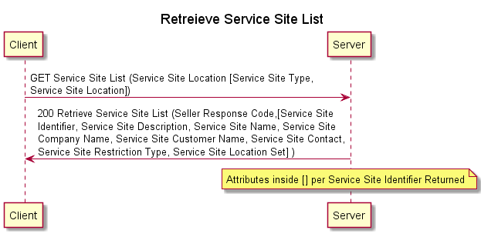

Figure 3 – Retrieve Service Site List Sequence Diagram

The Retrieve Service Site by ID sequence diagram is shown in Figure 4.

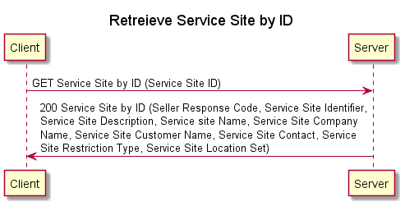

Figure 4 – Retrieve Service Site by ID Sequence Diagram

## MEF 79, MEF 79.0.1, and MEF 79.0.2 Requirements

All Site Retrieval requirements from MEF 79 [5], MEF 79.0.1 [6] and MEF 79.0.2 [7] are shown in the following tables.

### MEF 79 Requirements

The requirements from MEF 79 [5] are shown in Table 22.

| Requirement | Entity | Tested | Test Case | API Version | Comment |
| --- | --- | --- | --- | --- | --- |
| R17 | B | Y |  |  |  |
| O2 | B | N |  |  |  |
| R18 | B | Y |  |  |  |
| R19 | S | Y |  |  |  |
| R20 | S | Y |  |  | Retrieve Service Site List only |
| R21 | S | Y |  |  | Retrieve Service Site ID only |
| R22 | S | Y |  |  |  |
| R23 | S | Y |  |  |  |
| ~~R24~~ | ~~S~~ | ~~Y~~ |  |  | Deleted per MEF W79.0.2 [7] |
| O3 | S | N |  |  |  |
| R101 | SB | Y |  |  |  |
| ~~R102~~ | ~~SB~~ | ~~Y~~ |  |  | ~~Only if Service Site is GLOBAL_REFERENCE~~ Deleted per MEF 79.0.2 [7] |
| R103 | SB | Y |  |  | Only if Service Site is GEOGRAPHIC_POINT |
| R104 | B | Y |  |  | Only if Service Site is FIELDED_ADDRESS |
| R105 | B | Y |  |  | Only of Service Site is FORMATTED_ADDRESS |
| R106 | S | Y |  |  | Only if Service Site is FIELDED_ADDRESS |
| R107 | S | Y |  |  | Only of Service Site is FORMATTED_ADDRESS |

Table 22 – MEF 79 Requirements for Site Retrieval

### MEF 79.0.1 Requirements

There are no applicable requirements from MEF 79.0.1 [6].

### MEF 79.0.2 Requirements

The requirements from MEF 79.0.2 [7] are shown in Table 23.

| Requirement | Entity | Tested | Test Case Section | API Version | Comment |
| --- | --- | --- | --- | --- | --- |
| A2-R7 | S | Y |  |  |  |
| A2-R19 | SB | Y |  |  | Only if Service Site is GLOBAL_ADDRESS_REFERENCE |
| A2-R20 | S | Y |  |  | Only if Service Site is GEOGRAPHIC_POINT |
| A2-R21 | S | Y |  |  | Only if Service Site is GLOBAL_ADDRESS_REFERENCE |

Table 23 – MEF 79.0.2 Requirements for Site Retrieval

## Service Site Retrieval Test Cases

The Service Site Retrieval test cases are defined in the following sections.

### Retrieve Service Site List

The Retrieve Service Site List test cases are defined in this section.

### Retrieve Service Site by ID

The Retrieve Service Site by ID test cases are defined in this section.

# Product Offering Qualification Creation

The POQ Creation test requirements and test cases are defined in this section.

## POQ Creation Sequence Diagrams

The POQ Creation sequence diagram with a POQ Activity = INSTALL is shown in Figure 5.

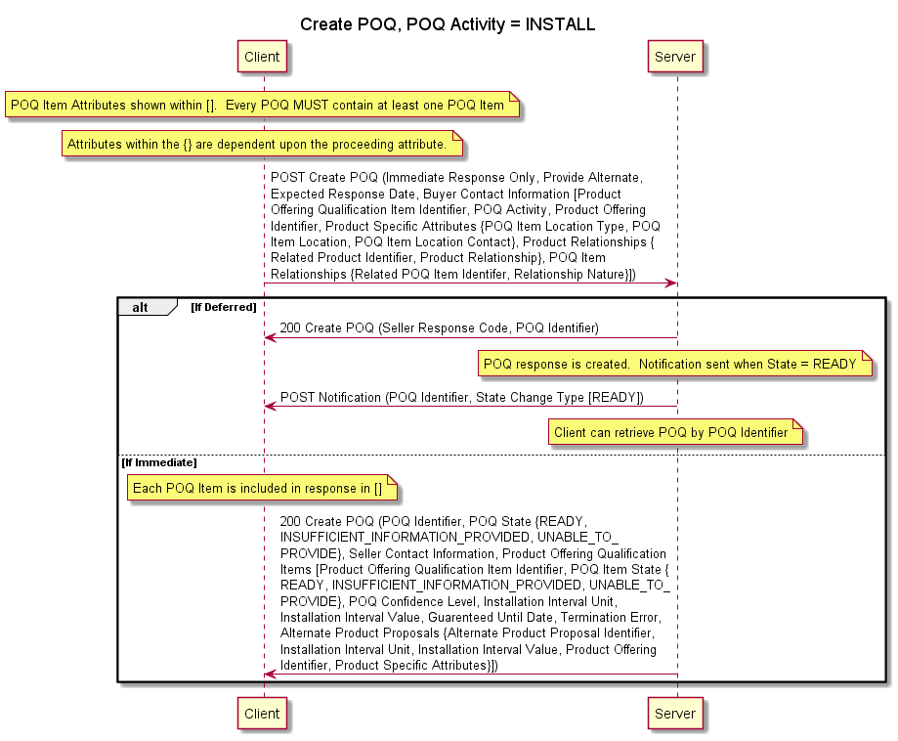

Figure 5 – POQ Creation POQ Activity = INSTALL Sequence Diagram

The POQ Creation sequence diagram with a POQ Activity = CHANGE is shown in Figure 6.

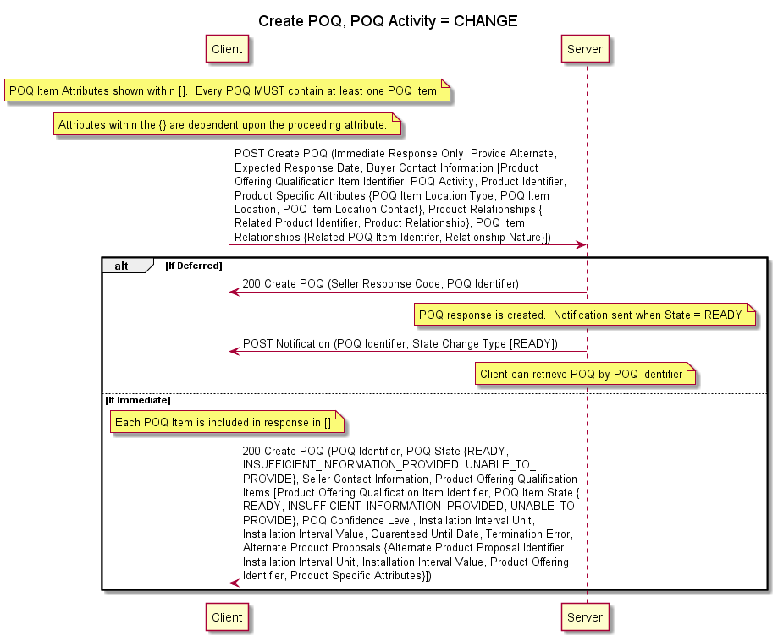

Figure 6 – POQ Creation POQ Activity = CHANGE Sequence Diagram

The POQ Creation sequence diagram with a POQ Activity = DISCONNECT is shown in Figure 7.

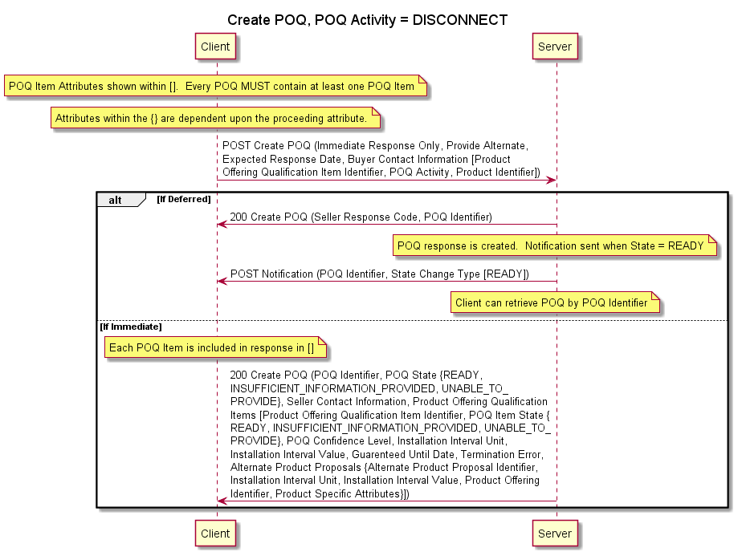

Figure 7 – POQ Creation POQ Activity = DISCONNECT Sequence Diagram

## MEF 79, MEF 79.0.1, and MEF 79.0.2 Requirements

All POQ Creation requirements from MEF 79 [5], MEF 79.0.1 [6] and MEF 79.0.2 [7] are shown in the following tables.

### MEF 79 Requirements

The requirements from MEF 79 [5] are shown in Table 22.

| Requirement | Entity | Tested | Test Case | API Version | Comment |
| --- | --- | --- | --- | --- | --- |
| R27 | B | Y |  |  |  |
| R28 | B | Y |  |  |  |
| O4 | B | N |  |  |  |
| R29 | B | Y |  |  |  |
| R30 | B | Y |  |  | Product Action = INSTALL |
| R31 | B | Y |  |  | Product Action = INSTALL |
| R32 | B | Y |  |  | Product Action = CHANGE or DISCONNECT |
| R33 | B | Y |  |  | Product Action = DISCONNECT |
| R34 | B | Y |  |  | Product Action = CHANGE |
| R35 | B | Y |  |  |  |
| R36 | B | Y |  |  |  |
| R37 | B | Y |  |  |  |
| R38 | B | Y |  |  |  |
| ~~R39~~ | ~~SB~~ | ~~Y~~ |  |  |  |
| R40 | S | Y |  |  |  |
| R41 | S | Y |  |  |  |
| R42 | S | N |  |  | Does not indicate success |
| R43 | S | Y |  |  |  |
| R44 | S | Y |  |  |  |
| R45 | S | Y |  |  |  |
| R46 | S | Y |  |  |  |
| R47 | S | Y |  |  |  |
| R48 | S | Y |  |  |  |
| R49 | S | N |  |  | Does not indicate success |
| R50 | S | Y |  |  |  |
| R51 | S | Y |  |  |  |
| R52 | S | Y |  |  |  |
| R53 | S | Y |  |  |  |
| R54 | S | Y |  |  |  |
| R55 | S | Y |  |  |  |
| R56 | S | Y |  |  |  |
| O5 | S | N |  |  |  |
| O6 | S | N |  |  | Discuss if we should test this one |
| R57 | S | N |  |  | If O6 is testable this is too |

Table 24 – MEF 79 Requirements for Create POQ

### MEF 79.0.1 Requirements

The requirements from MEF 79.0.1 [6] are shown in Table 25.

| Requirement | Entity | Tested | Test Case | API Version | Comment |
| --- | --- | --- | --- | --- | --- |
| A1-R1 | SB | Y |  |  |  |
| A1-R2 | SB | Y |  |  |  |
| A1-R3 | SB | Y |  |  |  |
| A1-R4 | SB | Y |  |  |  |
| A1-R5 | SB | Y |  |  |  |

Table 25 – MEF 79.0.1 Requirements for Create POQ

### MEF 79.0.2 Requirements

requirements from MEF 79.0.2 [7] are shown in .

| Requirement | Entity | Tested | Test Case | API Version | Comment |
| --- | --- | --- | --- | --- | --- |
| A2-R8 | S | Y |  |  |  |

Table 26 – MEF 79.0.2 Requirements for Create POQ

## POQ Creation Test Cases

The test cases for POQ Creation are defined in this section.

### Create POQ Product Action = INSTALL Test Cases

The test cases for creating a POQ with a Product Action = INSTALL are defined in this section.

### Create POQ Product Action = CHANGE Test Cases

The test cases for creating a POQ with a Product Action = CHANGE are defined in this section.

### Create POQ Product Action = DISCONNECT Test Cases

The test cases for creating a POQ with a Product Action = DISCONNECT are defined in this section.

# Product Offering Qualification Retrieval

The POQ Retrieval test requirements and test cases are defined in this section.

## POQ Retrieval Sequence Diagrams

The sequence diagrams for POQ Retrieval are shown in the following sections.

### Retrieve POQ List Sequence Diagram

The sequence diagram for Retrieve POQ List is shown in Figure 8.

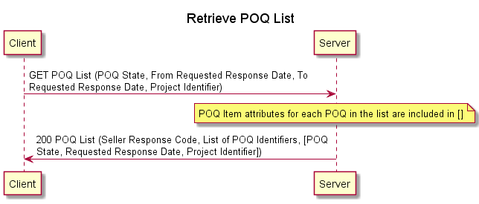

Figure 8 – Retrieve POQ List Sequence Diagram

### Retrieve POQ by ID Sequence Diagram

The sequence diagram for Retrieve POQ by ID is shown in Figure 9.

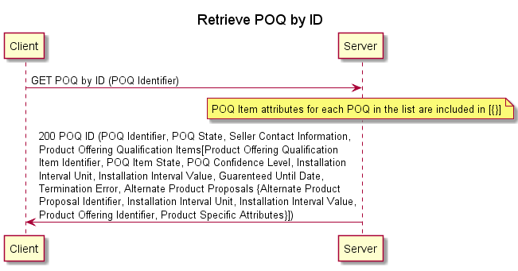

Figure 9 – Retrieve POQ by ID

## MEF 79, MEF 79.0.1, and MEF 79.0.2 Requirements

All Retrieve POQ requirements from MEF 79 [5], MEF 79.0.1 [6] and MEF 79.0.2 [7] are shown in the following tables.

### MEF 79 Requirements

The requirements from MEF 79 [5] that address a Retrieve POQ List request are shown in Table 27.

| Requirement | Entity | Tested | Test Case | API Version | Comment |
| --- | --- | --- | --- | --- | --- |
| O7 | B | Y |  |  | Specifies what can be used as filter criteria for Retrieve POQ List. |
| R60 | S | Y |  |  |  |
| R61 | S | Y |  |  |  |
| R62 | S | Y |  |  |  |
| R63 | S | Y |  |  |  |

Table 27 – MEF 79 Requirements for Retrieve POQ LIST

The requirements from MEF 79 [5] that address a Retrieve POQ by Identifier request are shown in Table 28.

| Requirement | Entity | Tested | Test Case | API Version | Comment |
| --- | --- | --- | --- | --- | --- |
| R64 | B | Y |  |  |  |
| R65 | S | Y |  |  |  |
| R66 | S | Y |  |  |  |
| R67 | S | Y |  |  |  |
| R68 | S | Y |  |  | READY |
| R69 | S | Y |  |  | INSUFFICIENT_INFORMATION_PROVIDED |
| R70 | S | Y |  |  | IN_PROGRESS, READY |
| R71 | S | Y |  |  | UNABLE_TO_PROVIDE |
| R72 | S | Y |  |  |  |
| R73 | S | Y |  |  | Negative Test Case |
| R74 | S | Y |  |  |  |
| R75 | S | Y |  |  |  |
| R76 | S | Y |  |  | INSUFFICIENT_INFORMATION_PROVIDED |
| R77 | S | Y |  |  | Termination Error when INSUFFICIENT_INFORMATION_PROVIDED |
| R78 | S | Y |  |  | READY |
| R79 | S | Y |  |  | READY state POQ Confidence Level is GREEN or YELLOW |
| O8 | S | N |  |  |  |
| ~~O9~~ | ~~S~~ | ~~Y~~ |  |  | ~~IN_PROGRESS or ABANDONED~~ |
| O10 | S | Y |  |  | READY state, POQ Confidence level is YELLOW or RED may provide Alternate Proposal |

Table 28 – MEF 79 Requirements for Retrieve POQ by Identifier

Note: R68 and R79 reference MEF 79 section 8.4.3.1 which includes the following requirements R50, R51, R52, R53, R54, R55, R56, O5, O6, and R57. The Seller POQ must include the attributes defined in these requirements.

### MEF 79.0.1 Requirements

There are no requirements within MEF 79.0.1 [6] that address Retrieve POQ List or Retrieve POQ by Identifier.

### MEF 79.0.2 Requirements

There are no applicable requirements from MEF 79.0.2 [7] that address Retrieve POQ List.

The requirements from MEF 79.0.2 [7] that address Retrieve POQ by Identifier are shown in Table 29.

| Requirement | Entity | Tested | Test Case | API Version | Comment |
| --- | --- | --- | --- | --- | --- |
| A2-R7 | S | Y |  |  | IN_PROGRESS or ABANDONED state |

Table 29 – MEF 79.0.2 Requirements for Retrieve POQ by Identifier

## Retrieve POQ List Test Cases

The test cases for retrieving a POQ List are defined in this section.

### Retrieve POQ List POQ State

The test cases for retrieving a POQ List using the POQ State as filter criteria are defined in this section.

### Retrieve POQ List Date Range

The test cases for retrieving a POQ List using a From Requested Response Date and To Requested Response Date as a filter criterion are defined in this section.

### Retrieve POQ List Project Identifier

The test cases for retrieving a POQ List using a Project Identifier as a filter criterion are defined in this section.

## Retrieve POQ by Identifier Test Cases

The Retrieve POQ by Identifier test cases are shown in the following sections.

### Retrieve POQ by Identifier Test Cases

The test cases for retrieving a POQ List are defined in this section.

# Product Offering Qualification Notification

The POQ Notification test requirements and test cases are defined in this section.

## Product Offering Qualification Notification Sequence Diagrams

The sequence diagrams for Product Offering Qualification Notification are shown in the following sections.

### Register for POQ Notifications

The sequence diagram for Register for POQ Notifications is shown in Figure 10.

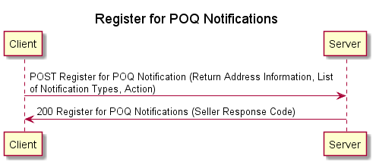

Figure 10 – Register for POQ Notifications Sequence Diagram

### POQ Notification Sequence Diagram

The sequence diagram for POQ Notification is shown in Figure 11.

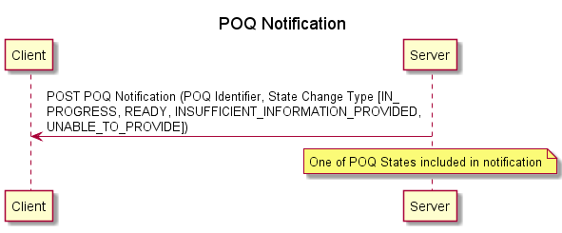

Figure 11 – POQ Notification

## MEF 79, MEF 79.0.1, and MEF 79.0.2 Requirements

All POQ Notification requirements from MEF 79 [5], MEF 79.0.1 [6] and MEF 79.0.2 [7] are shown in the following tables.

### MEF 79 Requirements

The requirements from MEF 79 [5] that address a Register for POQ Notifications request are shown in Table 30.

| Requirement | Entity | Tested | Test Case | API Version | Comment |
| --- | --- | --- | --- | --- | --- |
| R25 | B | Y |  |  | Per Notification Type and START and STOP |
| R26 | S | Y |  |  |  |

Table 30 – MEF 79 Requirements for Register for POQ Notification of State Change

The requirements from MEF 79 [5] that address a Seller sending a Notification of State Change are shown in Table 31.

| Requirement | Entity | Tested | Test Case | API Version | Comment |
| --- | --- | --- | --- | --- | --- |
| R58 | S | N |  |  |  |
| R59 | S | Y |  |  | CREATE and CHANGE. CHANGE should cover each POQ State. |

Table 31 – MEF 79 Requirements for POQ Notification

### MEF 79.0.1 Requirements

There are no requirements within MEF 79.0.1 [6] that address POQ Notification.

### MEF 79.0.2 Requirements

There are no applicable requirements from MEF 79.0.2 [7] that address POQ Notification.

## POQ Notification Test Cases

## Register for POQ Notifications Request Test Cases

The test cases for Register for PQO Notification test cases are shown in this section.

# Product Quote Creation

The Product Quote Creation test requirements and test cases are defined in this section.

## Product Create Quote Sequence Diagram

### Product Quote Create with Immediate Response = TRUE Sequence Diagram

The sequence diagram for a Quote with an Immediate Response is shown in Figure 12.

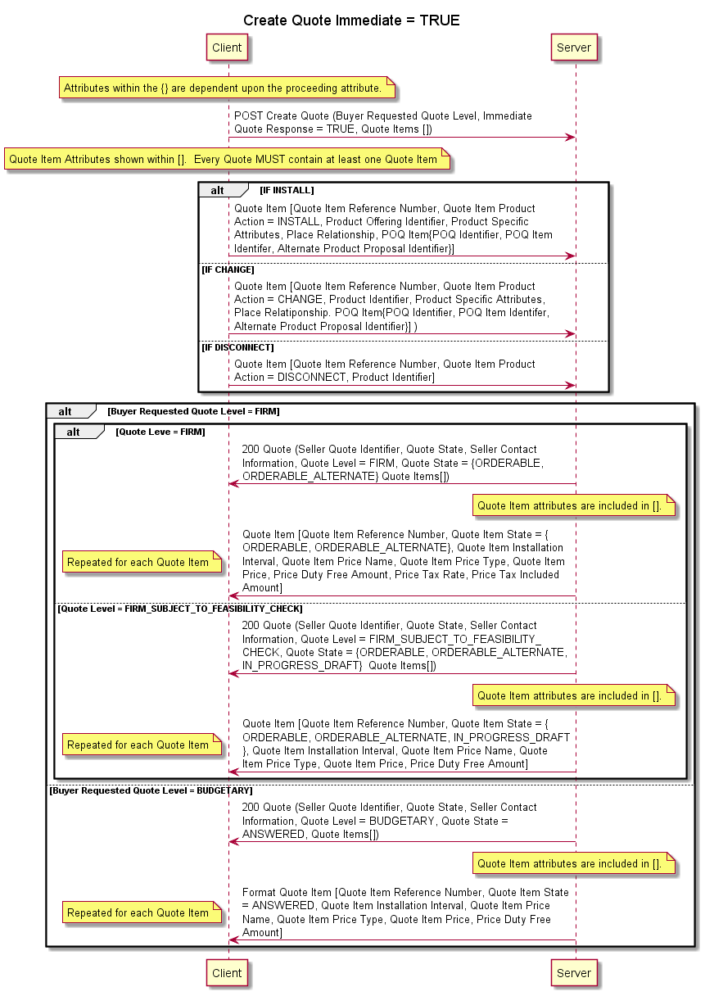

Figure 12 – Product Quote Create with Immediate Response = TRUE Sequence Diagram

### Product Quote Create with Immediate Response = FALSE Sequence Diagram

The sequence diagram for a Quote with a Deferred Response is shown in Figure 13.

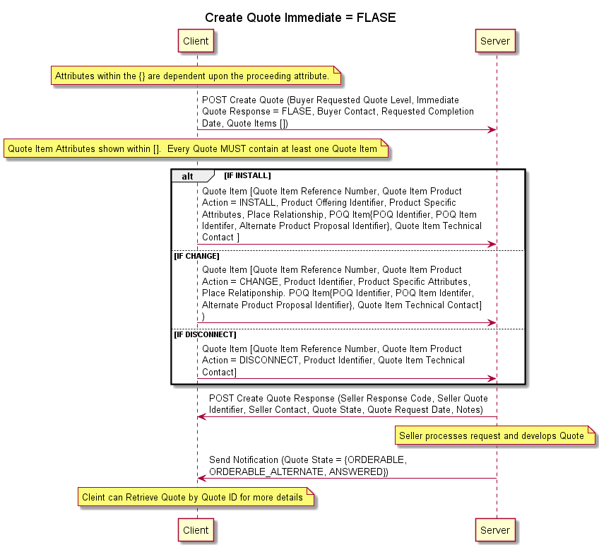

Figure 13 – Product Quote Create With Immediate Response = FALSE Sequence Diagram

### Product Quote Create with Immediate Response = FALSE Immediate Response Sequence Diagram

The sequence diagram for a Quote with a Deferred Response is shown Figure 14.

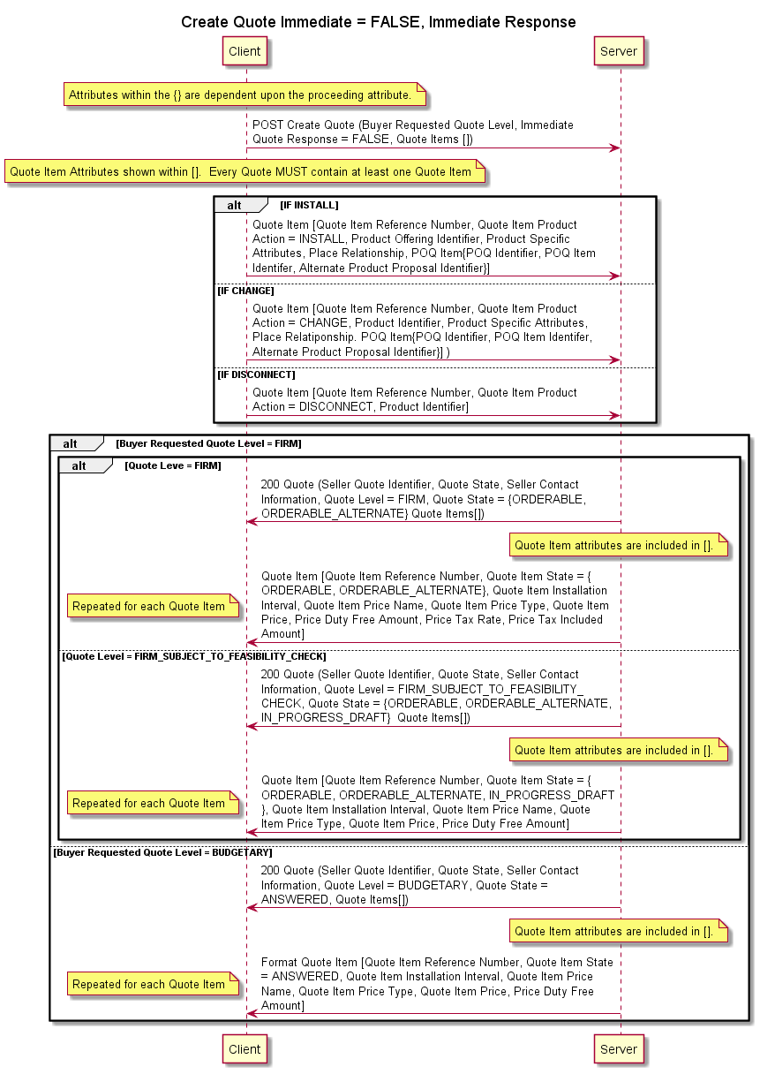

Figure 14 – Product Quote Create With Immediate Response = FALSE, Immediate Response Sequence Diagram

### Cancel Quote Sequence Diagram

The Cancel Quote sequence diagram is shown in Figure 15.

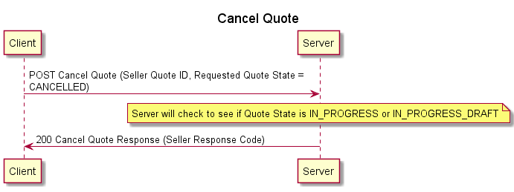

Figure 15 – Cancel Quote Sequence Diagram

### Reject Quote Sequence Diagram

The Reject Quote sequence diagram is shown in Figure 16.

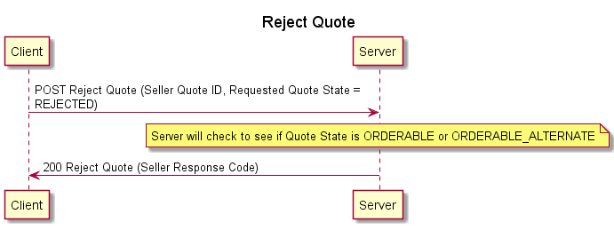

Figure 16 – Reject Quote Sequence Diagram

## MEF W80 Requirements

The requirements from MEF W80 that address Create Quote, Cancel Quote, or Reject Quote are shown in the following sections.

### Create Quote Requirements

The requirements from MEF 80 [8] for the Create Quote use cases are shown in Table 32.

| Requirement | Entity | Tested | Test Case | API Version | Comment |
| --- | --- | --- | --- | --- | --- |
| D1 | B | N |  |  |  |
| D2 | B | N |  |  |  |
| D3 | B | N |  |  |  |
| D4 | B | N |  |  |  |
| R1 | S | Y |  |  | Cancel a Quote |
| R2 | S | Y |  |  | Reject a Quote |
| R3 | S | Y |  |  | Seller Response Code |
| R4 | S | Y |  |  |  |
| R5 | S | Y |  |  |  |
| R6 | S | Y |  |  |  |
| R7 | S | Y |  |  |  |
| R8 | S | Y |  |  |  |
| R9 | SB | Y |  |  | Contact Information |
| O1 | SB | N |  |  |  |
| R10 | SB | Y |  |  | Note |
| R11 | S | Y |  |  |  |
| O2 | S | N |  |  |  |
| R12 | B | Y |  |  |  |
| R13 | B | Y |  |  |  |
| O3 | B | N |  |  |  |
| R14 | B | Y |  |  |  |
| R15 | B | Y |  |  | Immediate = False |
| R16 | B | Y |  |  | Immediate = False |
| R17 | B | Y |  |  | Immediate = False |
| R18 | S | Y |  |  | Immediate = true |
| O4 | SB | N |  |  |  |
| CR1<O4 | B | N |  |  |  |
| R19 | B | Y |  |  | Product Action = INSTALL |
| O5 | B | N |  |  | Product Action = INSTALL |
| CR2<O5 | B | N |  |  |  |
| R20 | B | Y |  |  |  |
| R21 | B | Y |  |  |  |
| R22 | B | Y |  |  | Immediate = FALSE |
| R23 | B | Y |  |  | Alternate Product Proposal |
| R24 | B | Y |  |  | Must not include Alternate Product Proposal |
| R25 | B | Y |  |  |  |
| O6 | B | N |  |  |  |
| R26 | B | Y |  |  | Product Action = CHANGE |
| R27 | B | Y |  |  | Product Action = CHANGE |
| O7 | B | N |  |  |  |
| CR3<O7 | B | N |  |  |  |
| R28 | B | Y |  |  | Product Action = DISCONNECT |
| R29 | B | Y |  |  | Product Action = DISCONNECT |
| R30 | B | Y |  |  | Product Action = DISCONNECT |
| R31 | B | Y |  |  | Product Action = DISCONNECT |
| R32 | S | Y |  |  |  |
| R33 | S | Y |  |  |  |
| R34 | S | Y |  |  |  |
| R35 | S | Y |  |  |  |
| R36 | S | Y |  |  |  |
| R37 | S | Y |  |  | Buyer Requested Quote Level = FIRM |
| R38 | S | Y |  |  | DELETING REQUIREMENT |
| R39 | S | Y |  |  | Buyer Requested Quote Level = BUDGETARY |
| R40 | S | Y |  |  |  |
| R41 | S | Y |  |  |  |
| R42 | S | Y |  |  |  |
| R43 | S | Y |  |  |  |
| R44 | S | Y |  |  | DELETING REQUIREMENT |
| R45 | S | Y |  |  | Quote Item State = ORDERABLE or ANSWERED |
| R46 | S | Y |  |  | Quote Item State = ORDERABLE_ALTERNATE |
| R47 | S | Y |  |  | Quote Item State = ORDERABLE, ORDERABLE_ALTERNATE, or ANSWERED |
| R48 | S | Y |  |  |  |
| R49 | S | Y |  |  |  |
| R50 | S | Y |  |  | UNABLE_TO_PROVIDE |
| R51 | S | Y |  |  | INSUFFICIENT_INFORMATION_PROVIDED or ABANDONED |
| R52 | S | Y |  |  | INSUFFICIENT_INFORMATION_PROVIDED |
| R53 | S | Y |  |  |  |
| O8 | S | N |  |  |  |
| R54 | S | Y |  |  | ORDERABLE |
| R55 | S | Y |  |  | Quote Item Price Type = RECURRING |
| R56 | S | Y |  |  |  |
| R57 | S | Y |  |  | Quote Item Price Type = USAGE_BASED |
| R58 | S | Y |  |  | Seller End of Term Action = ROLL |
| R59 | S | Y |  |  | Seller End of Term Action ≠ ROLL |
| D5 | SB | N |  |  |  |
| R60 | S | Y |  |  | Immediate = TRUE |
| R61 | S | Y |  |  | Immediate = TRUE |
| R62 | S | Y |  |  | Immediate = TRUE |
| R63 | S | Y |  |  | Immediate = TRUE |
| R64 | S | Y |  |  | Immediate = TRUE |
| R65 | S | Y |  |  | Immediate = TRUE |
| R66 | S | Y |  |  | Immediate = TRUE |
| R67 | S | Y |  |  | Immediate = TRUE |
| O9 | S | Y |  |  | Immediate = TRUE |
| R68 | S | Y |  |  | Immediate = FALSE |
| R69 | S | Y |  |  | Immediate = FALSE |
| R70 | S | Y |  |  | Immediate = FALSE |
| R71 | S | Y |  |  | Immediate = FALSE |
| R72 | S | Y |  |  | Immediate = FALSE |
| R73 | S | Y |  |  | Immediate = FALSE, Immediate provided |
| R74 | S | Y |  |  | Immediate = FALSE, Immediate provided |
| R75 | S | Y |  |  | Immediate = FALSE, Immediate provided |
| R76 | S | Y |  |  | Immediate = FALSE, Immediate provided |

Table 32 – MEF 80 Requirements for Create Quote

### MEF W80 Cancel or Reject Quote Requirements

The requirements from MEF 80 [8] for the Cancel or Reject Quote use cases are shown in Table 33.

| Requirement | Entity | Tested | Test Case | API Version | Comment |
| --- | --- | --- | --- | --- | --- |
| R1 | S | Y |  |  |  |
| R2 | S | Y |  |  |  |
| R77 | B | Y |  |  | Cancel or Reject |
| O10 | B | N |  |  |  |
| R78 | S | Y |  |  | Cancel or Reject |

Table 33 – MEF 80 Requirements for Cancel or Reject Quote

## Product Quote Create Test Cases

The test cases for Create Product Quote are defined in this section.

### Request Create Product Quote with Immediate Response = TRUE

### Request Create Product Quote with Immediate Response = FALSE

### Response Create Product Quote with Immediate Response = FALSE Immediate Response

### Request Cancel Product Quote

### Buyer Request Reject Product Quote

### Response Reject Product Quote

# Product Quote Retrieval

The POQ Creation test requirements and test cases are defined in this section.

## Product Quote Retrieval Sequence Diagrams

The sequence diagrams for Retrieve Product Quote are shown in the following sections.

### Retrieve Product Quote List Sequence Diagram

The Retrieve Product Quote List sequence diagram is shown in Figure 17.

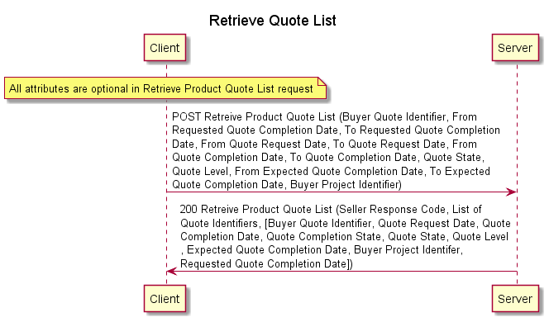

Figure 17 – Retrieve Product Quote List Sequence Diagram

### Retrieve Product Quote by Quote ID Sequence Diagram

The Retrieve Product Quote by Quote ID sequence diagram is shown in Figure 18.

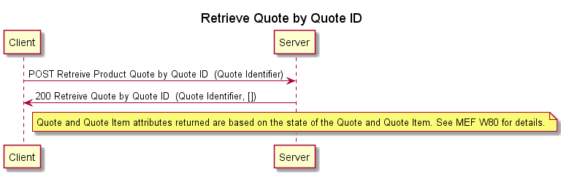

Figure 18 – Retrieve Product Quote by Quote ID Sequence Diagram

## MEF W80 Requirements

The requirements from MEF W80 that address Retrieve Product Quote and Retrieve Product Quote by ID are shown in the following sections.

### Retrieve Product Quote

The requirements from MEF 80 [8] for the Retrieve Product Quote use case are shown in Table 34.

| Requirement | Entity | Tested | Test Case | API Version | Comment |
| --- | --- | --- | --- | --- | --- |
| O11 | B | Y |  |  |  |
| O12 | B | Y |  |  |  |
| O13 | B | Y |  |  |  |
| R79 | S | Y |  |  |  |

Table 34 – MEF 80 Requirements for Retrieve Product Quote

### MEF W80 Retrieve Product Quote by Quote ID Requirements

The requirements from MEF 80 [8] for the Retrieve Product Quote by Quote ID use case are shown in Table 35.

| Requirement | Entity | Tested | Test Case | API Version | Comment |
| --- | --- | --- | --- | --- | --- |
| R81 | B | Y |  |  |  |
| R82 | S | N |  |  | Negative Case |
| R83 | S | N |  |  | Negative Case |
| R84 | S | Y |  |  | Quote Level = FIRM, FIRB_SUBJECT_TO_FEASIBILITY_CHECK |
| R85 | S | Y |  |  | Quote Level = BUDGETARY |
| R86 | S | Y |  |  |  |
| R87 | S | Y |  |  |  |
| R88 | S | Y |  |  |  |
| R89 | S | Y |  |  |  |
| R90 | S | Y |  |  |  |
| R91 | S | Y |  |  |  |

Table 35 – MEF 80 Requirements for Retrieve Product Quote by Quote ID

## Retrieve Product Quote Test Cases

### Retrieve Product Quote List Test Case

### Retrieve Product Quote by Quote ID Test Case

# Product Quote Notification

The Product Quote Notification test requirements and test cases are defined in this section.

## Product Quote Notification Sequence Diagrams

The Product Quote Notification sequence diagrams are shown in the following sections.

### Register for Product Notification Sequence Diagram

The Register for Quote Notifications sequence diagram is shown in Figure 19.

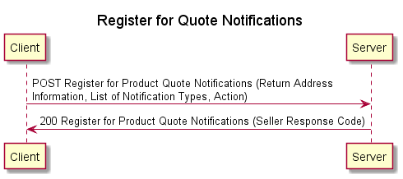

Figure 19 – Register for Quote Notifications Sequence Diagram

### Send Product Quote Notification Sequence Diagram

The Send Product Quote Notification sequence diagram is shown in Figure 20.

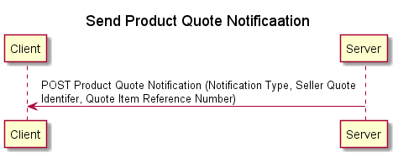

Figure 20 – Send Product Quote Notification Sequence Diagram

## MEF W80 Requirements

The requirements from MEF W80 that address registering for and sending notifications are shown in the following sections.

### Register for Product Quote Notifications Requirements

The requirements from MEF 80 [8] for the Register for Product Quote Notifications use case are shown in Table 36.

| Requirement | Entity | Tested | Test Case | API Version | Comment |
| --- | --- | --- | --- | --- | --- |
| R92 | B | Y |  |  |  |
| R93 | B | Y |  |  |  |
| R94 | B | Y |  |  |  |
| R95 | S | Y |  |  |  |

Table 36 – MEF 80 Requirements for Register for Product Notifications

### MEF W80 Send Product Quote Notifications Requirements

The requirements from MEF 80 [8] for the Send Notifications use case are shown in Table 37.

| Requirement | Entity | Tested | Test Case | API Version | Comment |
| --- | --- | --- | --- | --- | --- |
| O14 | S | Y |  |  | May support notifications |
| CR4<O14 | S | Y |  |  | If notifications are supported |
| CR5<O14 | S | Y |  |  | If notifications are supported |
| CR6<O14 | S | Y |  |  | If notifications are supported |
| CR7<O14 | S | Y |  |  | If notifications are supported |
| CR8<O14 | S | Y |  |  | If notifications are supported |

Table 37 – MEF 80 Requirements for Send Notifications

## Product Quote Notification Test Cases

### Register for Product Quote Notifications Test Case

### Send Notification Test Case

# Product Inventory

The Product Inventory test requirements and test cases are defined in this section.

## Product Inventory Sequence Diagrams

The Product Inventory sequence diagrams are shown in the following sections.

### Product Inventory Retrieve Product List Sequence Diagram

The Product Inventory Retrieve Product List sequence diagram is shown in Figure 21.

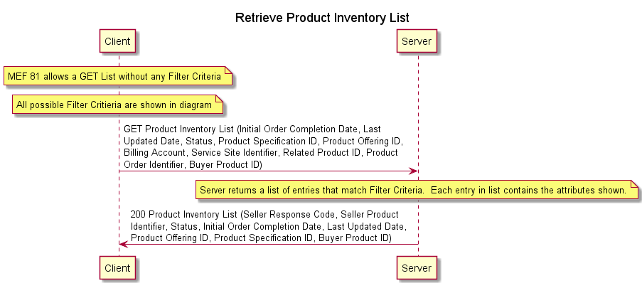

Figure 21 – Product Inventory Retrieve Product List Sequence Diagram

### Product Inventory Retrieve Product by ID Sequence Diagram

The Product Inventory Retrieve Product by ID sequence diagram is shown in Figure 22.

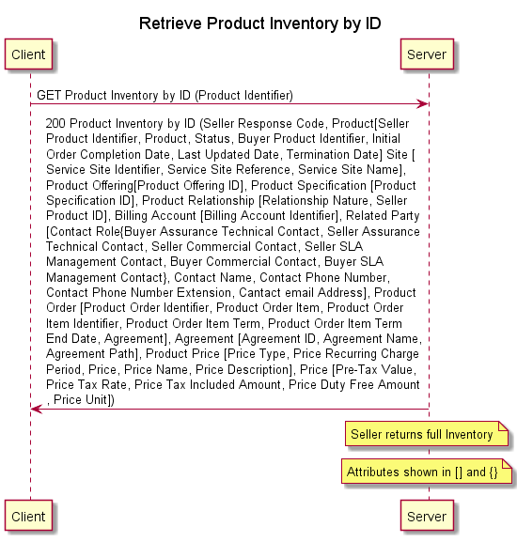

Figure 22 – Product Inventory Retrieve Product by ID Sequence Diagram

## MEF 81 and 81.0.1 Requirements

### Product Inventory Retrieve List Requirements

The requirements from MEF 81 [9] for the Product Inventory Retrieve List use case are shown in Table 38.

| Requirement | Entity | Tested | Test Case | API Version | Comment |
| --- | --- | --- | --- | --- | --- |
| R1 | SB | Y |  |  |  |
| R2 | S | Y |  |  |  |
| R3 | B | Y |  |  |  |
| R4 | S | Y |  |  |  |
| R7 | B | Y |  |  |  |
| O1 | B | N |  |  |  |
| R8 | S | Y |  |  |  |
| O2 | S | N |  |  |  |
| O3 | S | N |  |  |  |
| R12 | B | N |  |  | Buyer ID Requirement |
| R13 | B | N |  |  | Buyer ID Requirement |
| R14 | S | N |  |  | Seller ID Requirement |
| R15 | S | N |  |  | Seller ID Requirement |
| R16 | S | Y |  |  |  |
| R17 | S | Y |  |  |  |

Table 38 – Product Inventory Retrieve List Requirements

Note MEF 81.0.1 [10] does not contain any requirements.

### Product Inventory Retrieve Product ID Requirements

The requirements from MEF 81 [9] for the Product Inventory Retrieve by Product ID use case are shown in Table 39.

| Requirement | Entity | Tested | Test Case | API Version | Comment |
| --- | --- | --- | --- | --- | --- |
| R1 | SB | Y |  |  |  |
| R2 | S | Y |  |  |  |
| R5 | B | Y |  |  |  |
| R6 | S | Y |  |  |  |
| R9 | B | Y |  |  |  |
| R10 | S | Y |  |  |  |
| R11 | S | Y |  |  |  |
| R12 | B | N |  |  | Buyer ID Requirement |
| R13 | B | N |  |  | Buyer ID Requirement |
| R14 | S | N |  |  | Seller ID Requirement |
| R15 | S | N |  |  | Seller ID Requirement |
| R16 | S | Y |  |  |  |
| R17 | S | Y |  |  |  |

Table 39 – Product Inventory Retrieve Product ID Requirements

Note: MEF 81.0.1 [10] does not contain any requirements.

## Product Inventory Test Cases

### Product Inventory Retrieve List Test Cases

### Product Inventory Retrieve Product ID Test Cases

# Product Order Creation, Retrieval, and Notification

1. This section to be provided in a later release of the document.

# References

1. IETF RFC 2119, *Key words for use in RFCs to Indicate Requirement Levels*, March 1997
2. IETF RFC 8174, *Ambiguity of Uppercase vs Lowercase in RFC 2119 Key Words*, May 2017
3. MEF 55, *Lifecycle Service Orchestration (LSO): Reference Architecture and Framework*, March 2016
4. MEF 57.2 Draft Standard R2, *Product Order Management Requirements and Use Cases*, November 2020
5. MEF 79, *Address, Service Site, and Product Offering Qualification Management Requirements and Use Cases*, November 2019
6. MEF 79.0.1, *Amendment to MEF 79: Address, Service Site, and Product Offering Qualification Management Requirements and Use Cases*, July 2020
7. MEF 79.0.2 Draft Standard R1, *Amendment to MEF 79: Address Validation*, November 2020
8. MEF 80 Draft Standard R5, *Quote Management Requirements and Use Cases*, November 2020
9. MEF 81, *Product Inventory Management Requirements and Use Cases*, November 2019
10. MEF 81.0.1, *Amendment to MEF 81: Product Inventory Management*, February 2020